Day 3 : Test Runs & Execution
Learnt
- What a Test Run is
- Test statuses and meaning
- Difference:
  - Test Run vs Test Plan
Practical
- Created a Test Run
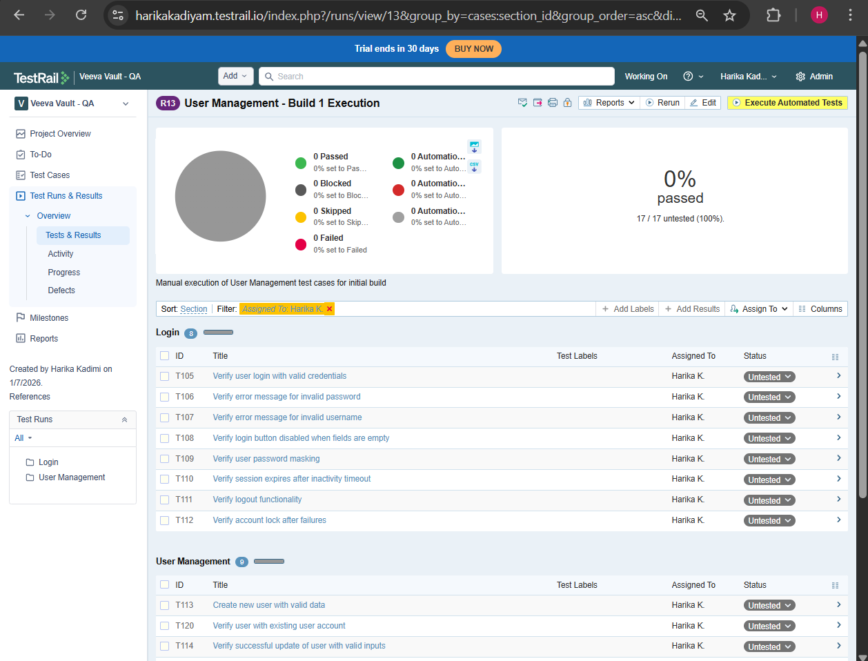
- Selected test cases from suites
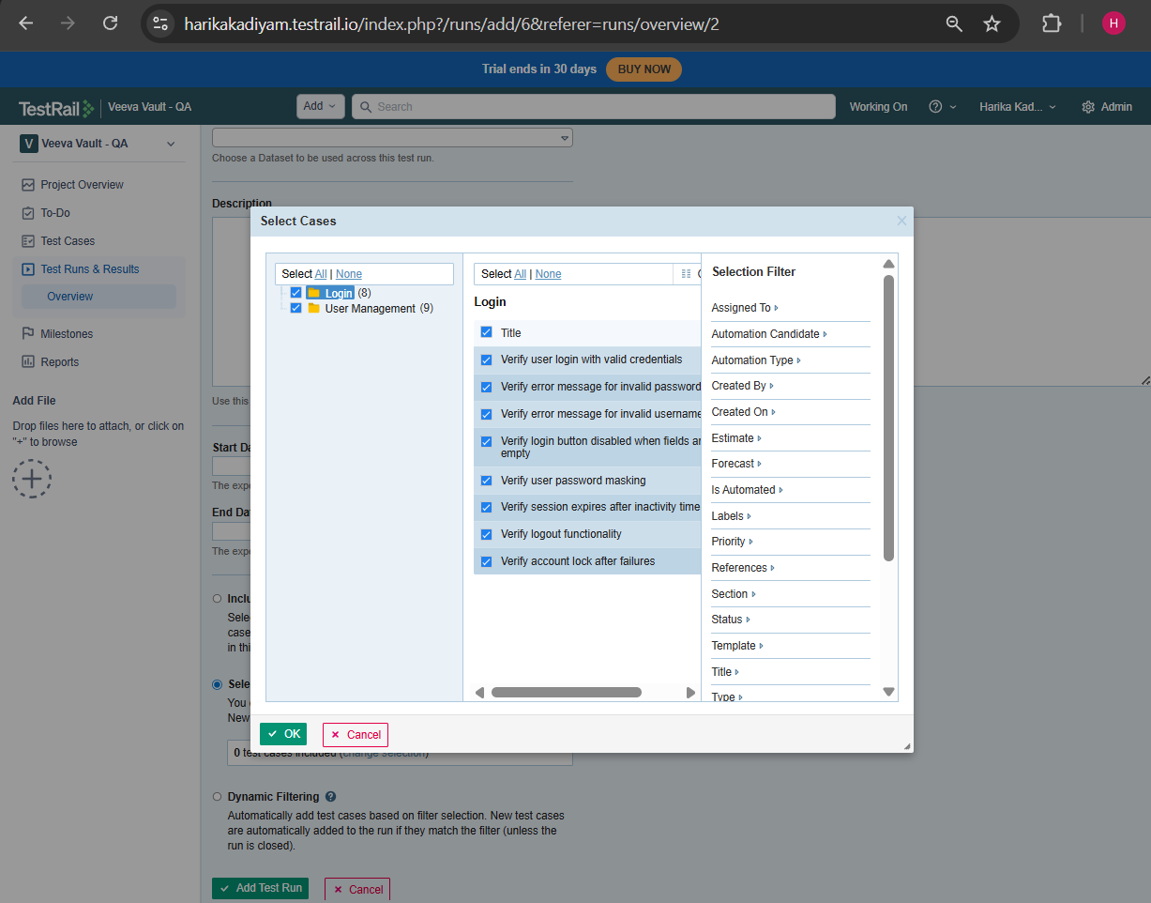
- Executed test cases:
  - Passed
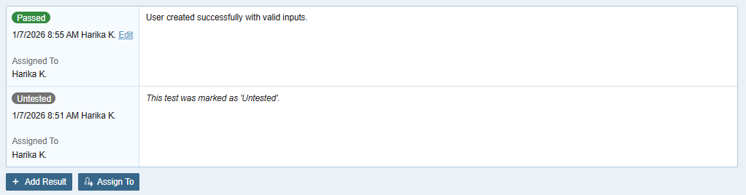
  - Failed
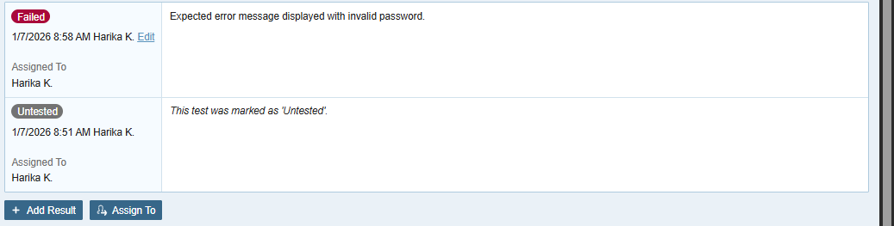
  - Blocked
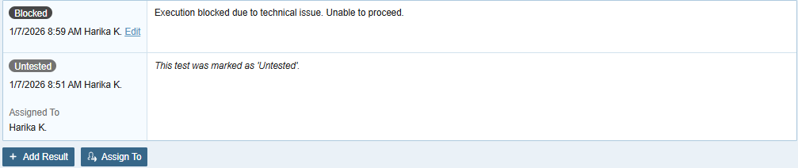
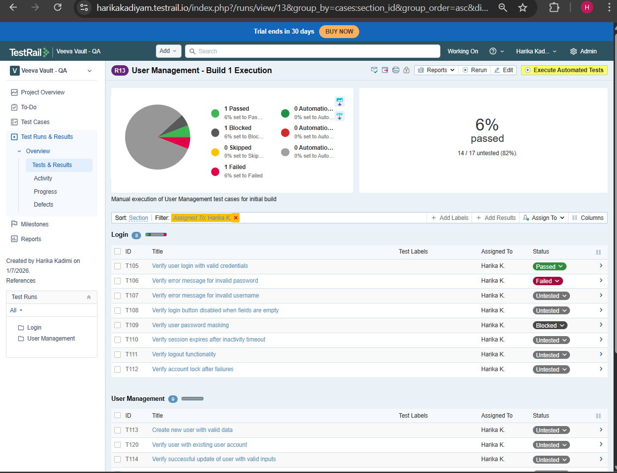
- Added execution comments
